****Major categories that make up the General Fund expenditures include: Salaries & Wages (46.2%), Fringe Benefits (17.6%), Services & Materials (10.7%), Other Operating (11.7%), and Capital Outlay (0.2%). The remaining expenditures consist of transfers out of the General Fund to fund debt service and other direct charges from other funds (13.6%).

A description of each expenditure category as well as a discussion and outlook over the next five years follows.

**Salaries & Wages**

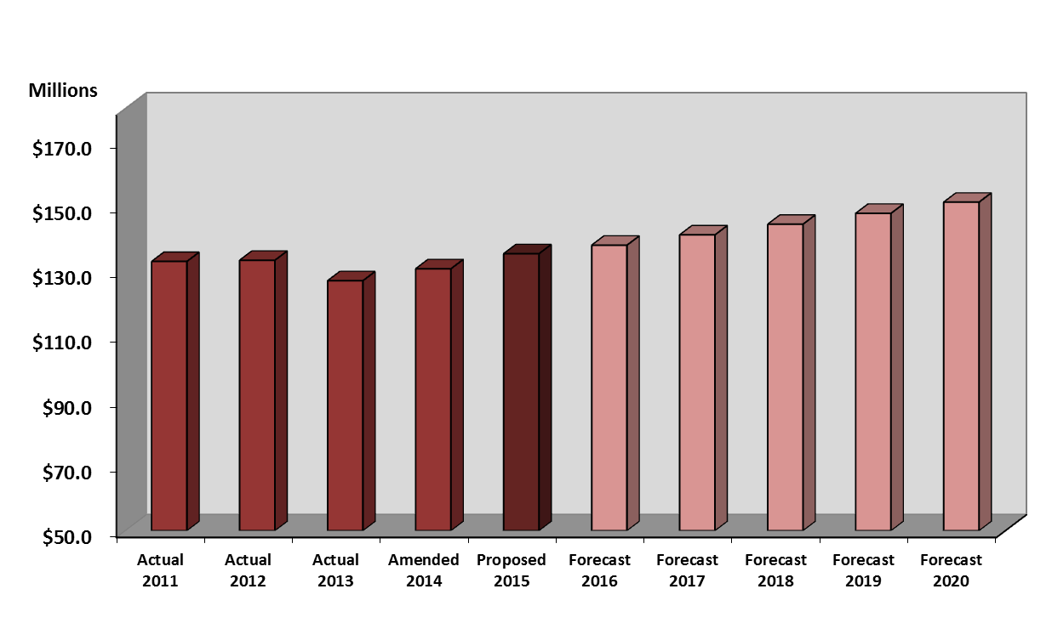This is the largest expenditure category and represents 46.2% of all General Fund expenditures, excluding balances and reserves. The major expenses in this category include the following: salaries, other wages, overtime, and longevity. The proposed expenditure for FY 2015 is $135,323,295, which represents a 3.5% increase from the FY 2014 amended budget and includes all contractually obligated wage increases.

**Fringe Benefits**

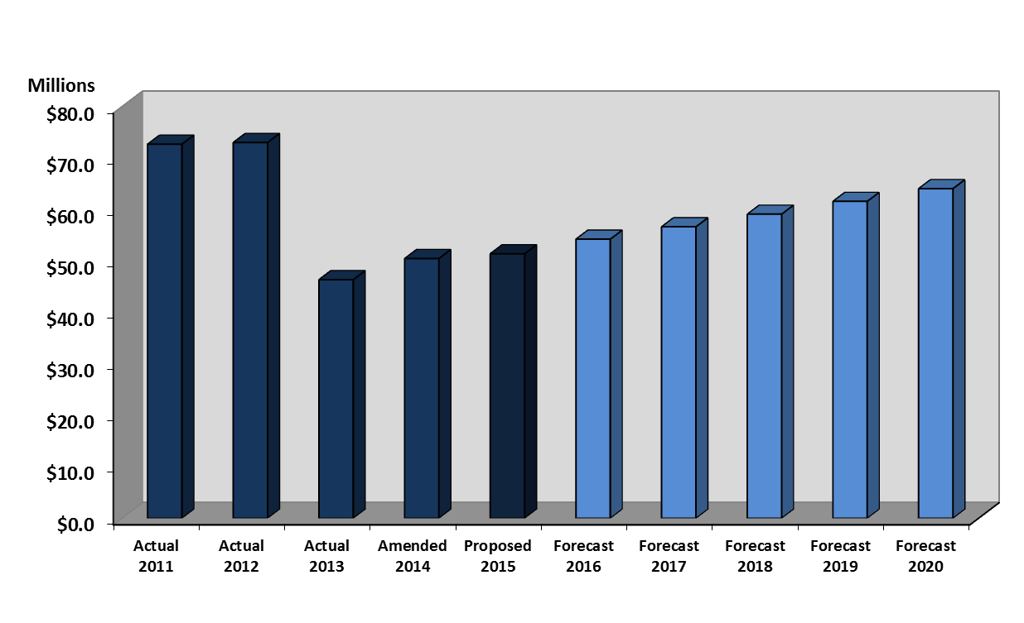This expenditure category includes pension, social security, health care, and retiree health care. The proposed budget for FY 2015 is $51,406,739, which represents a 1.9% increase from the FY 2014 amended budget, primarily due to insurance premiums and contributions towards pensions. The projection includes a 2.5% annual increase over the next five years. The steep decline from FY 2012 to FY 2013 is due to the issuance of Pension Obligation Bonds to fund the unfunded liability portion of our annual contribution to our General Employees Retirement System (GERS) and Police and Fire pensions.

**Services & Materials**

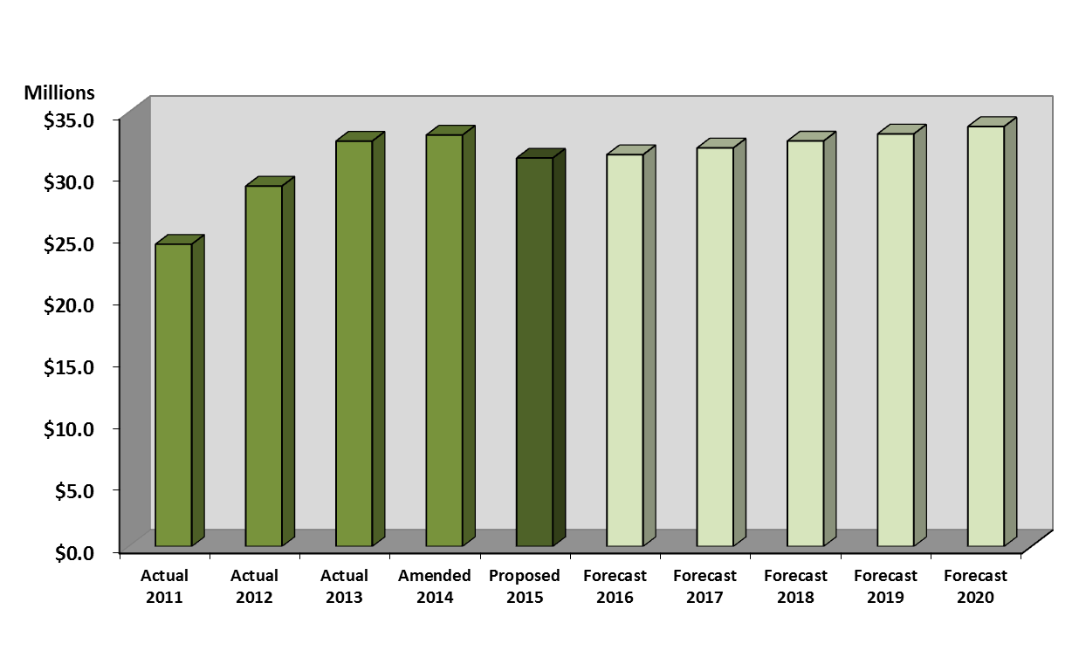This expenditure category includes electricity, gasoline, supplies, equipment, other services, and other utilities. The proposed budget for FY 2015 is $31,325,192, which represents a 5.6% decrease from the FY 2014 amended budget. For FY 2015, Emergency 911 Call Center costs have been removed due to the new integrated Broward County regional system, which will provide countywide services. Over the next five years, the projection is a stable inflationary factor of 1.2% for the cost of supplies and services.

**Other Operating Expenditures**

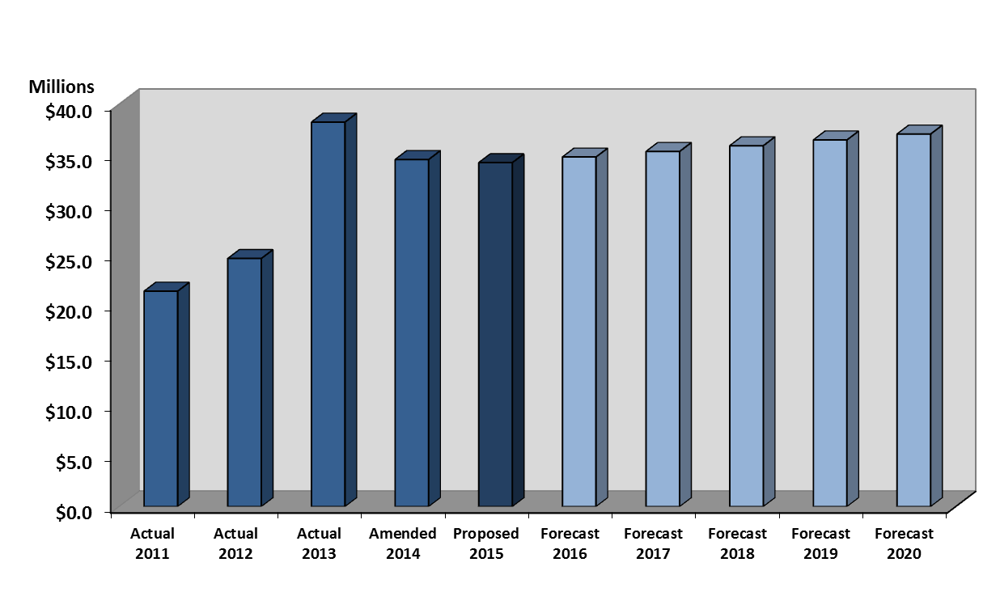This expenditure includes staff training and certifications, liability and property insurance premiums, information technology interfund service charges, fleet related operating charges. The proposed budget for FY 2015 is $34,196,501, which represents a .9% decrease from the FY 2014 amended budget, which is primarily due to decreases in the cost of information technology interfund service charges and fleet related charges.

**Capital Outlay**

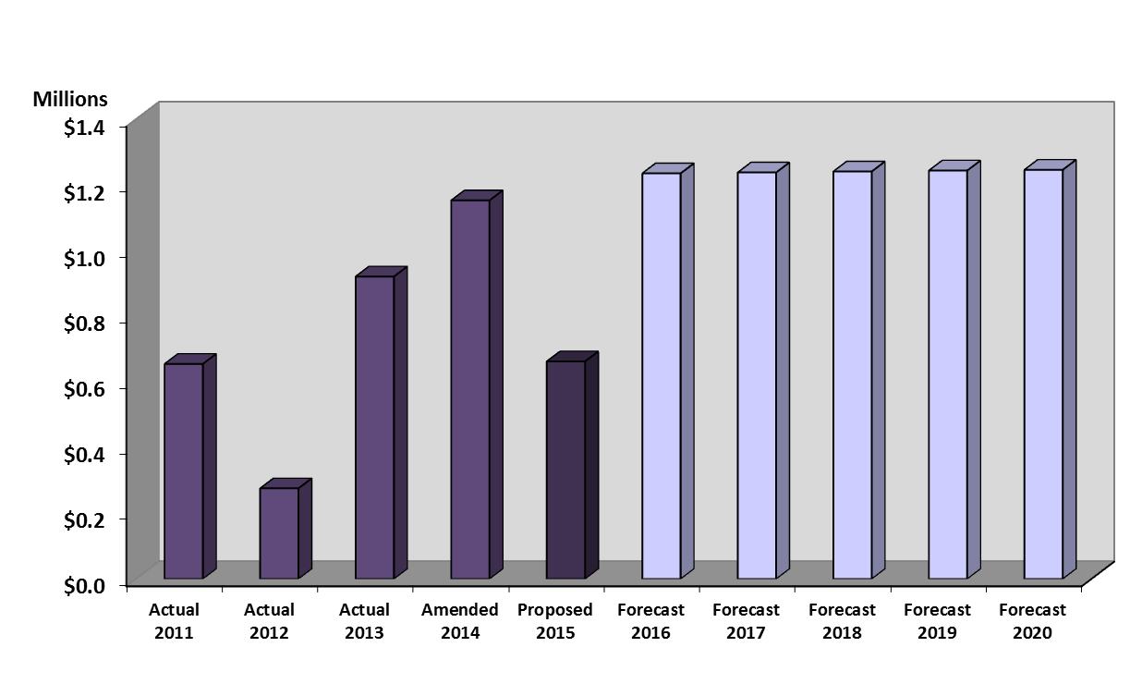This expenditure category includes fixed assets that are durable in nature and cost at least $5,000. The proposed budget for FY 2015 is $662,298, which is .2% of the General Fund expenditures. The FY 2015 capital outlay budget proposes upgraded information technology, office renovations, and repair and maintenance equipment. Capital outlay is not for capital project improvements. All General Fund related capital projects are funded via a transfer out from the General Fund to the General Capital Projects Fund. The General Fund capital improvement transfer for FY 2015 is $6.85 million.